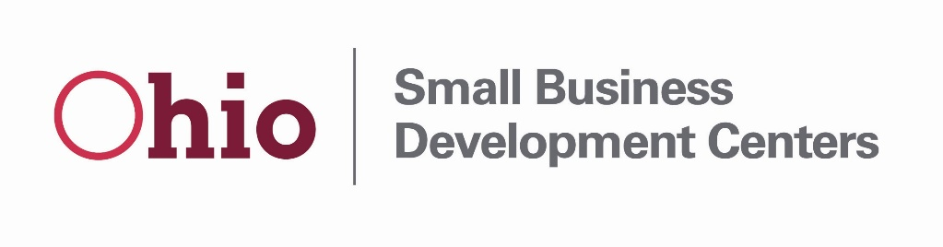
FFY2020 Ohio SBDC ACF Questionnaire
Applicant Name (Host):
Primary Contact:
Email:
Telephone:

- Provide a brief description of any proposed service delivery changes compared to your FFY2018 proposal or FFY 2019 ACF questionnaire:

- Provide a brief description of any significant budgetary changes as compared to your FFY2019 budget proposal.

- Funding: Provide a brief description of how a funding increases of ten percent funding would be utilized by the center. Please identify estimated costs and explain if your center would have available local cash match (standard cash match requirements apply). Outline how your center would re-budget based on a ten percent cut of grant funding.

- Please provide a justification for your proposed goals:

Proposed Strategic Plan Alignment:
Our Mission Statement - Accelerate Business Success
Our Vision Statement - To be the resource for business expertise!

Our Values:
Economic Impact – the reason for our existence
Service – the spirit with which we work
Guidance – the nature of our efforts
Collaboration – the openness we possess to work with others

Directions: For each of our four strategic pillars below please outline any proposed projects, initiatives or activities that align with Ohio SBDC
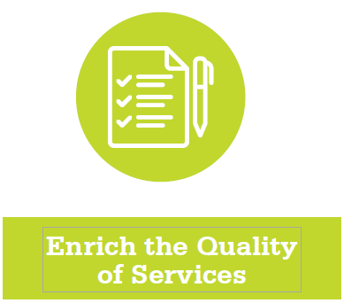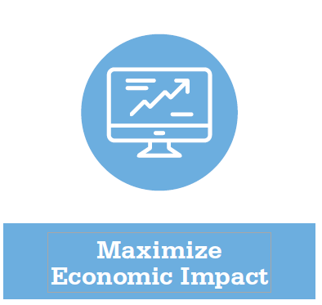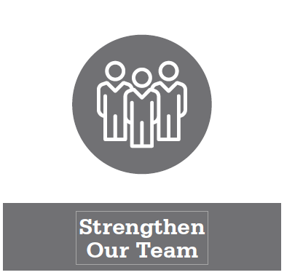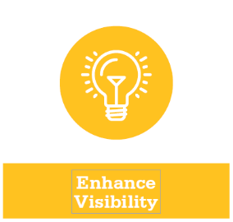

- Enrich Quality of Services: Design key services and processes to ensure flexibility and responsiveness to evolving client needs.
- Desired Outcomes: Improved Client Satisfaction.
- Examples: New programming in response to local needs, designing/implementing new measures or outreach to identify business needs, developing processes for regular evaluation of satisfaction data etc.

Add your center projects or tactics here:

- Maximize Economic Impact: Drive activities that engage high performing clients and refine processes that ensure the capture of quality impact.
- Desired outcomes: Increased engagement of high performing clients, especially existing businesses and improved capture of impact.
- Examples: implementing time/case management procedures to focus activities on existing business clients, developing trainings/processes to streamline interactions with non-productive pre-venture clients, creating systems and processes that increase rate of impact capture etc.

Add your center projects or tactics here:

- Strengthen Our Team: Invest to develop key skills, increase communication across the SBDC network, and share and implement best practices.
- Desired Outcomes: Increase the skill sets of our advisors, enhance ability to be more responsive to customers’ needs, increased communication, collaboration and referrals in the SBDC network.
- Examples: Increased participation on statewide SBDC committees (marketing, CBA, Statewide Conference), regional collaboration on events, marketing or other initiatives with other SBDCs, development of Individual Professional Development Plans for staff, other training investments for staff.
Add your center projects or tactics here:

- Enhance Visibility: Continued development of activities and messaging to engage targeted, impact generating, client segments. Multiply outreach through identification and outreach to top referrers.
- Desired Outcomes: Increased awareness of Ohio SBDC, especially to our top referrers (banks, the economic development community) funders, other key stakeholders and desired local client segments.
- Examples: Redevelopment of the marketing and stakeholder engagement plan, conducting market research on new organizations to engage, development of new locally targeted marketing materials etc.
Add your center projects or tactics here:

- SBA Specific Information: The SBA has requested we provide an overview of services offered in the following specific categories. In the spaces below, please list any planned activities related business segments in any of the following categories. If the center does not have any specific activities under a topic area, leave blank.
SBIR, STTR or tech transfer from federal labs or state universities:

Guidance or Training related to Cyber Security:

Targeted Assistance to Veterans:

Targeted Assistance to disadvantaged businesses including Minority-owned, Women-owned and Rural businesses:

