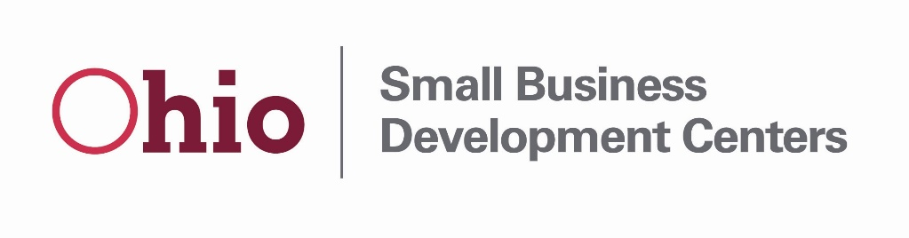
FFY2021 Ohio SBDC ACF Questionnaire
Applicant Name (Host):
Primary Contact:
Email:
Telephone:

- Provide a brief description of any proposed service delivery changes compared to your FFY2020 program year.

- Provide a brief description of Center services or trainings focused on rural small businesses.

- Is your center planning any training or services related to intellectual property or technology transfer during the FFY 2021 program year? Please indicate if your center is willing to collaborate with the Lead Center on hosting an intellectual property or technology transfer training.

- Additional Funding Opportunities: It is possible that the SBDC program will have access to carry over funding or increased congressional appropriations. Provide a brief description of a need or request for any how additional funding would be utilized by the center. Please identify estimated costs and available local cash match (standard cash match requirements apply, any existing overmatch would qualify for additional funds).

