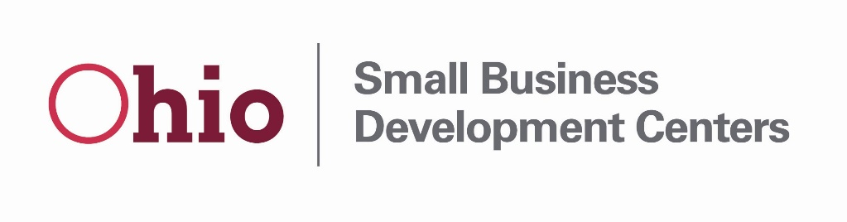
FFY2022 Ohio SBDC ACF Questionnaire
Applicant Name (Host):
Primary Contact:
Email:
Telephone:
Fiscal Contact (if different):
Email:
Telephone:

- Provide a brief description of any proposed service delivery changes compared to your FFY2020 program year.

- Provide a brief description of targeted services, trainings or collaborations with the following client segments or organizations:
Underserved Communities, (as defined by the SBA Navigators- Women, Rural, Minority, Veteran):

Historically Black Colleges and Universities (HBCUs):

Federal Export Resources (U.S. Commerce, EXIM, SBA etc.):

USDA Programs:

SBA District Offices:

- Is your center planning any training or services related to intellectual property or technology transfer during the FFY 2021 program year? Please indicate if your center is willing to collaborate with the Lead Center on hosting an intellectual property or technology transfer training.

- Is your center planning any training or services related to intellectual cyber security in 2022? Please indicate if your center is willing to collaborate with the Lead Center on hosting an intellectual property or technology transfer training.

- Is your SBDC launching ore continuing any new initiatives, innovative programming or training that merits being highlighted in our cooperative application to the SBA?

