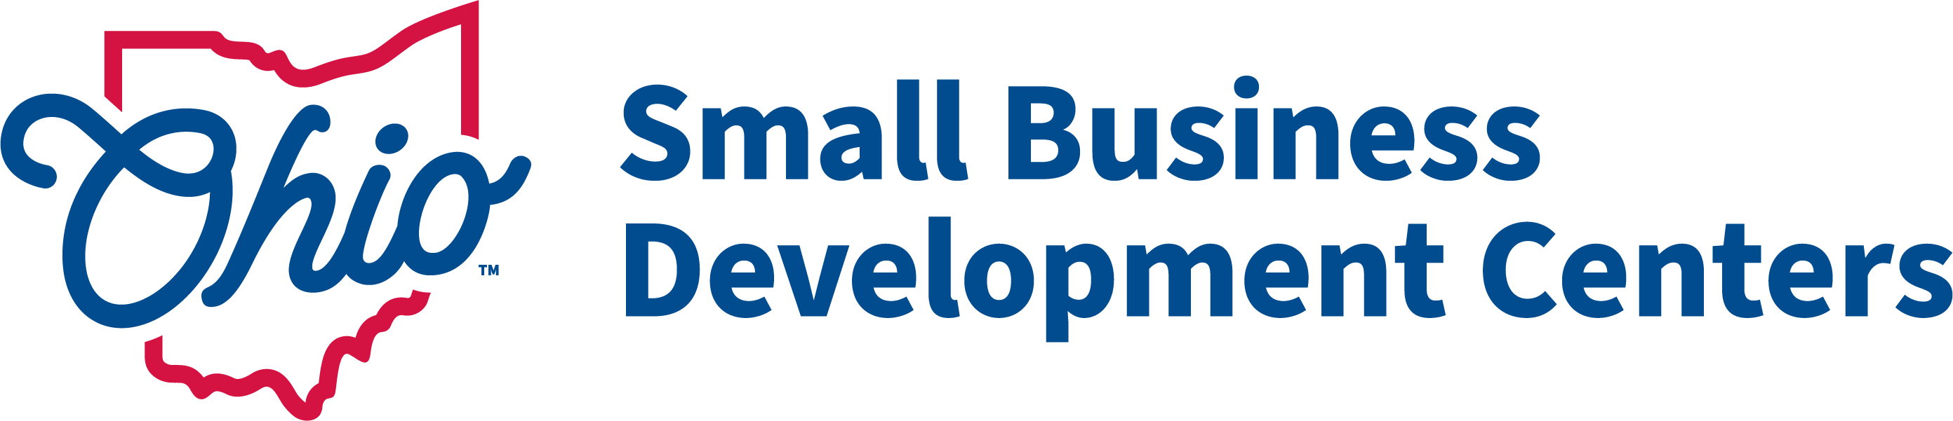
CY2024 Ohio SBDC ACF Questionnaire

Applicant
Name (Host Organization):
Primary Contact (Center Director):
Email:
Telephone:

Fiscal Contact (if different):
Name, Title:
Email:
Telephone:

Host Representative (individual to whom the SBDC Director Reports)
Name, Title:
Email:
Telephone:

List SBDC Service Center Primary Location(s):
Defined as: locations open during regular business hours with at least one dedicated full-time or equivalent staff.

Center Name:
Center Address:

Center Name:
Center Address:

Center Name:
Center Address:

SBDC Service Center Satellite Location(s)
Defined as: Locations that contain dedicated SBDC office space (office space not used by other programs) and is regularly staffed by SBDC advisers, though not on a full-time basis (A satellite location would not include standing office hours at in a meeting room at a library or incubator).

Center Name:
Center Address:

- Provide a brief description of any newly proposed services or significant changes compared to your CY 2024 program year.

- Provide a brief description of targeted services, trainings or collaborations with the following client segments or organizations (SBA Issued Priority Groups) You may mark categories as N/A:
Underserved Communities, (as defined by the SBA Navigators- Women, Rural, Minority, Veteran):

Historically Black Colleges and Universities (HBCUs):

Federal Export Resources (U.S. Commerce, EXIM, SBA etc.):

Childcare Providers:

USDA Programs:

SBA District Offices:

- Is your center planning any training or services related to intellectual property, technology transfer or cyber security during the CY2024 program year? Please indicate if your center is willing to collaborate with the Lead Center on hosting intellectual property or technology transfer training.

- Is your SBDC launching or continuing any new initiatives, innovative programming, or training that you feel merits being highlighted in our cooperative agreement application to the SBA (be sure to include export promotion initiatives if your center hosts an SBDC Export Assistance program)?

- For the 2024 Program Year the SBA is no longer recognizing “training only” clients. In order to “claim” clients they will need to participate in at least one advising session. In response to these program changes, briefly outline your center’s approach for its training strategy in 2024 and any efforts to convert training only clients to advised clients.

- Workforce: Maintaining our professional SBDC workforce will continue to be critical to SBDC success in 2024. Does your center offer competitive wages and benefits to maintain a strong SBDC workforce? If not, what is limiting the host organization from being able to offer a competitive salary and benefits?

- Please Provide a brief Justification for your proposed goals.

