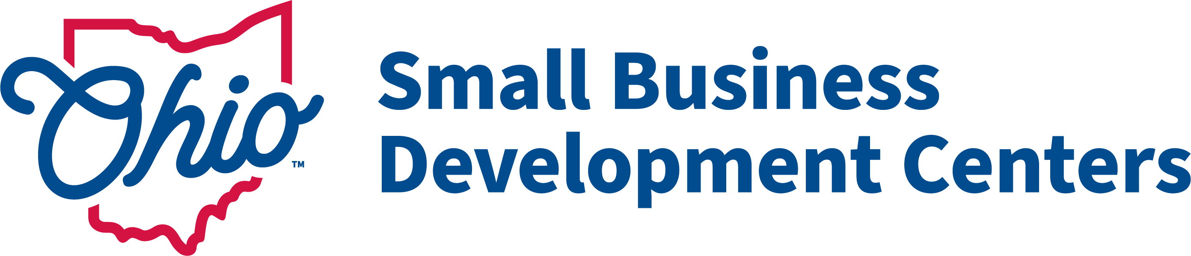
CY2025 Ohio SBDC ACF Questionnaire

Applicant
Name (Host Organization):
Primary Contact (Center Director):
Email:
Telephone:

Fiscal Contact (if different):
Name, Title:
Email:
Telephone:

Host Representative (individual to whom the SBDC Director Reports)
Name, Title:
Email:
Telephone:

List SBDC Service Center Primary Location(s):
Defined as: locations open during regular business hours with at least one dedicated full-time or equivalent staff.

Center Name:
Center Address:

Center Name:
Center Address:

Center Name:
Center Address:

SBDC Service Center Satellite Location(s)
Defined as: Locations that contain dedicated SBDC office space (office space not used by other programs) and is regularly staffed by SBDC advisers, though not on a full-time basis (A satellite location would not include standing office hours at in a meeting room at a library or incubator).

Center Name:
Center Address:

- Provide a brief description of any newly proposed services or significant changes compared to your CY 2024 program year.

- Provide a brief description of targeted services, trainings or collaborations with the following client segments or organizations (SBA Issued Priority Groups) You may mark categories as N/A:
Underserved Communities, (As Defined by SBA: Women, Rural, Minority, LGBTQ etc.):

Veterans:

Historically Black Colleges and Universities (HBCUs):

Federal Export Resources (U.S. Commerce, EXIM, SBA etc.):

Childcare Providers:

USDA Programs:

Planned SBA District Office collaborations:

- Is your center planning any training or services related to intellectual property, technology transfer or cyber security during the CY2025 program year? Please indicate if your center is willing to collaborate with the Lead Center on hosting intellectual property or technology transfer training.

- Is your SBDC launching or continuing any new initiatives, innovative programming, or training that you feel merits being highlighted in our cooperative agreement application to the SBA (be sure to include export promotion initiatives if your center hosts an SBDC Export Assistance program)?

- Strategically aligned Initiatives – Highlight any specific strategically aligned initiatives or efforts planned in 2025:
- Efforts to educate the banking community on SBDC services, or collaborations with the banking community on SBDC service delivery with members of the banking community:

- Efforts to educate members of the economic development community on SBDC services or collaborations with the economic development community on service delivery:

- Efforts to implement and deploy the InquisIT business assessment tool (note a training cohort will be offered in early 2025 – each SBDC is required to have at least one InquisIT certified adviser):

- Other Strategically aligned efforts (Enrich the quality of services, Maximize Economic Impact, Strengthen our Team, Enhance Visibility):

- Please Provide a brief Justification for your proposed goals:

